**Experiment no – 01 (F)**

**Aim:** Write a recursive function to print the factorial for a given number.

**Theory:-**

**Practical Implementation**:-

**Code**:-

def recur_factorial(n):

if n == 1:

return n

else:

return n*recur_factorial(n-1)

num = int(input("Enter the number ="))

if num < 0:

print("Sorry, factorial does not exist for negative numbers")

elif num == 0:

print("The factorial of 0 is 1")

else:

print("The factorial of", num, "is", recur_factorial(num))

**Output:-**

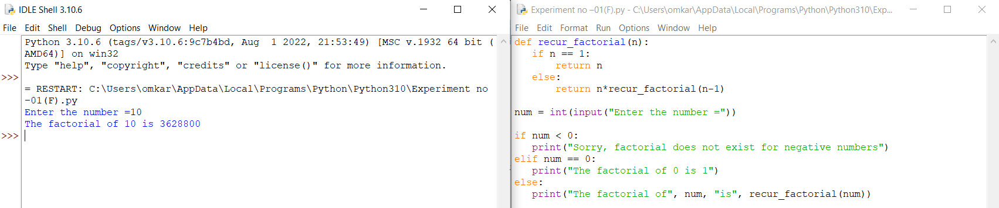

**Conclusion:-** This is program successfully run.